**ER Diagram**

This diagram is generated from MySQL.

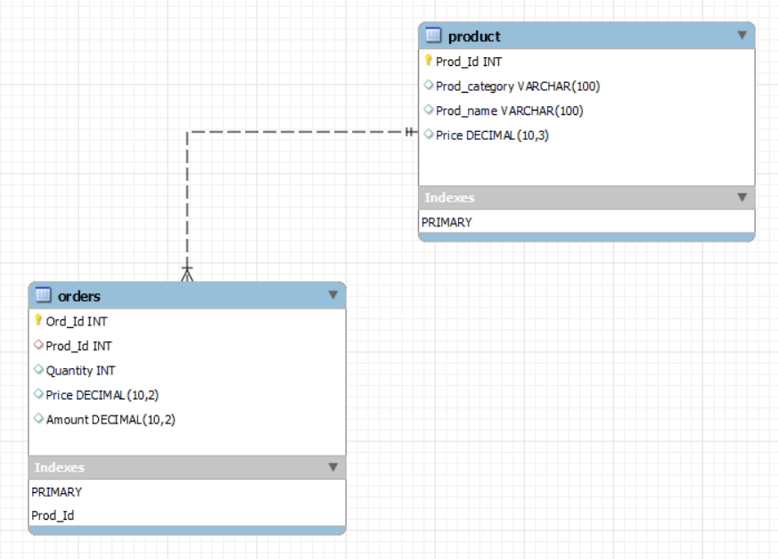

* **ER diagram**

Here 1—M means one to many relationship

**Orders - Product Relationship**

* One order can contain multiple products.
* Therefore, this is the **one-to-many** relationship, we can order multiple products on each order.

Orders

1

Have

Product

M